Lab 3

1. For 1 explained with code

2. Here we are given the positional uncertainty between two images of stars which we already know that they don’t align properly due to atmospheric and instrumental effects. If a plot is made to show the movement of stars, we end up with a 2D Gaussian distribution with sigma =1 and mean = 0. Since we were only looking for the movement of stars the detection of movement of an asteroid would pop up as a 5-sigma signal since it is a rare possibility for asteroid data to come in while tracking stars. Thus in order to find that 5 sigma signal we integrate the cumulative gaussian function as shown below and equate it to 3.5x10-6 (i.e. 5-sigma value)

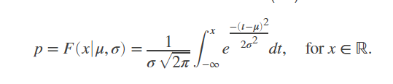

Using the following equation and then equating this to 5sigma value in both directions to find a (x,y) point for the 5-sigma signal showing us the movement of an asteroid in our data. In matlab I try to replicate the data and one can calculate the sigma values using the method described above.

3. Similar to the last question here we look at the cosmic background radiation and track the moon size patch for 8 hours every night for 15 days. The moon sized patch gives out 1 ray per minute at random intervals. Thus in order to set up the background we assume that we get a 1 cosmic rays per minute but when the moon shadow is there the rate of cosmic ray changes (thus creating a time dependence). Thus, in other words we can setup a distribution where the total number of rays(7200 counts of rays if constant at 1ray/min) collected over 15 days with lambda at 6800 counts as our signal and the background spanning till 7200 rays if the rate of cosmic ray detection is constant at 1ray/minute. In order to calculate the sigma value we create a gaussian distribution using normpdf and then integrate the distribution and equate it to 1 in a million chance to find the value of sigma on the original signal(which is a poisson distribution due to the discrete nature of cosmic ray detection i.e. either there is 1 or 0 thus a binary form of counts in established).

In order to find significance of our data we use z-scores and t-score values to calculate the signifance of our data. In respect with the t-score we get a p-value <0.05 thus our data is statistically significant for the moon shadow.